Datasheet
Armiti Zigbee Wifi-Ethernet Room Module AR1302.02

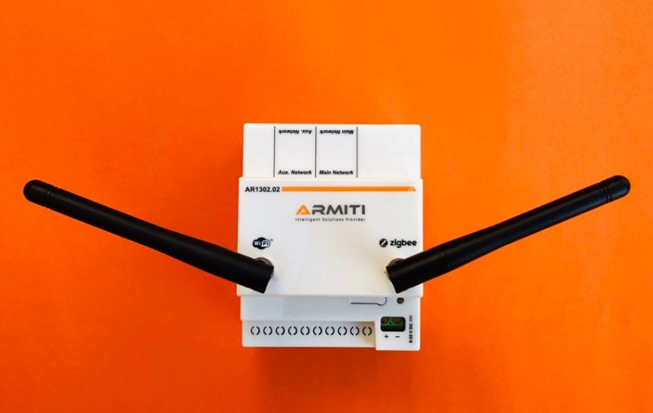 | The KNX-Zigbee Room Gateway is a perfect solution to integrate VingCard ZigBee door locks with KNX/IP networks for KNX hotel solutions such as ABB i-bus KNX® systems.  The device connects securely the Vingcard and KNX subsystems -as a Gateway- and passes/converts information through their different protocols. It further conveys the activity reports and commands to/from the Vingcard and KNX servers. The device further provides unique IP addresses allowing connection to local network through wired (Ethernet 10/100) or wireless (WiFi) communication.

Key Features
- Provides Secure Wired/Wireless Connection to KNX Networks
- Supports All KNX Telegrams
- Transparent to ETS Server activities
- Integrated Securely with KNX System and ETS server
- Conveys Vingcard Door Lock Events to the Visionline Server Securely
- Performs KNX Scenarios Locally According to Door Events
- Wired (Ethernet 10/100) Network Connection to KNX IP Interfaces
- Wireless (ZigBee) Connection to Door Lock
- Provides Unique IP Per Room on Wireless or Wired Local Network
- Logs all the Desired Status and Communication Information
- Decision Making on Special Events and Performing Predefined Scenarios on KNX Network
- Lots of Add-on Features
- Supports Configuration after Installation through the Device Secure Web Interface
- Small/Light Package

Technical data
Wired Connections | 1x Power Connector  2x Ethernet (10/100) Connectors
Wireless Connections | ZigBee  WiFi
Enclosure | IP20 DIN
Working Temperature | 0 to 70 °C
Ambient condition | Maximum Air Humidity 93 %, No Condensation Allowed
Design | Modular installation device (MDRC)  4MW  Dimensions (WxHxD) 10x90x10 mm
Weight | 0.138 kg
Installation | On 35 mm mounting rail
CE mark | In Accordance with the EMC Guideline and Low Voltage Guideline (TBD)
Housing Color | White/Gray
Input Power Supply | 9 to 32 Volts DC
 | Supports current IP Interfaces Supply - (12‐30 VDC)
Power Consumption | Peak 10 Watts, Typical 4 Watts (3 Watts with WiFi off)
Antennas | 2xExternal
Communication | Ethernet  Wireless WiFi, IEEE802.11 (b/n/g) 2.4 GHz  Wireless Zigbee, IEEE 802.15.4 2.4 GHz
Buttons | 1x Commissioning Push Button
LEDs | 1x Status LED  2x Ethernet Activity LEDs, One LED on Each of 2 Connectors

